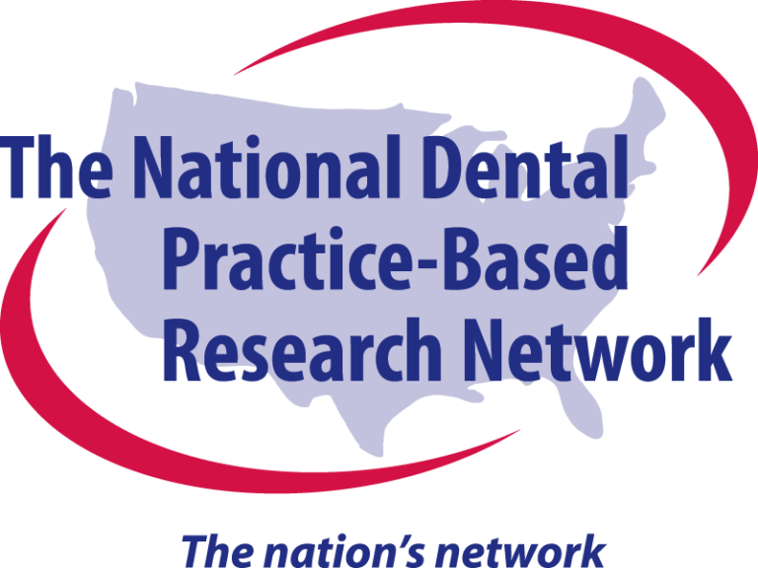
Antibiotic effectiveness in Periodontics: Unlocking research opportunities with the PAAS trial

The Periodontal Adjunctive Antibiotics Study (PAAS) will assign patients with periodontitis to receive either Amoxicillin + Metronidazole or placebo as an adjunct treatment to scaling and root planing. Over 12 months, we will track periodontal clinical parameters, complications, and patient satisfaction.
- Misuse of antibiotics poses a growing threat, jeopardizing both patient health and microbial resistance.
- Current guidelines lack strong evidence,^{1,2} leading to confusion and inconsistencies in prescribing practices.
- PAAS will bridge the gap, providing definitive data to establish clear, optimal antibiotic utilization strategies.
Study Details:
- Double-blind, randomized clinical trial design: Testing Amoxicillin + Metronidazole as adjunct to non-surgical periodontal therapy (scaling and root planing).
- Data collection:
  - Practitioners will record full mouth probing depth, bleeding on probing, gingival recession, etc. at baseline, 6-week, and 1-year follow-up visits and upload periodontal charts via a user-friendly web form.
  - Practitioners will dispense Amoxicillin + Metronidazole or placebo to their patients in conjunction to scaling and root planing (SRP) treatment.
  - Patients will complete short web-based surveys at baseline, 10 days after baseline, and at the 6-week and 1-year follow-up visits.
  - Both practitioners and patients will report on adverse events throughout the study.
- Sample size: 544 patients from 36 practices in the South Central, Southwest, and Western Network Regions.
- Outcomes:
  - Primary: Improved clinical parameters of probing depth, and bleeding on probing at 1 year as primary outcome
- Effect of adjunctive antibiotics on other clinical parameters (gingival recession, attachment level).
- Identify factors associated with high response to adjunctive antibiotics.
- Evaluate the safety and tolerability of adjunctive antibiotics.
Potential benefits for practitioners and their patients:
- Shape the future of periodontal therapy. Your data will directly influence future clinical guidelines, with clear protocols for antibiotic use, optimizing both patient care and antibiotic stewardship.
- Benefit your patients. Advance scientific knowledge to deliver the best possible periodontal care.
Current study status:
- X participants from X practices were randomly assigned to test or placebo groups
- Expected end of enrollment is XXX, 202X.

[1] Smiley CJ, Tracy SL, Abt E, Michalowicz BS, John MT, Gunsolley J, Cobb CM, Rossmann J, Harrel SK, Forrest JL, Hujoel PP, Noraian KW, Greenwell H, Frantsve-Hawley J, Estrich C, Hanson N. Systematic review and meta-analysis on the nonsurgical treatment of chronic periodontitis by means of scaling and root planing with or without adjuncts. J Am Dent Assoc. 2015 Jul;146(7):508-24.e5. doi: 10.1016/j.adaj.2015.01.028. PMID: 26113099.
[2] Smiley CJ, Tracy SL, Abt E, Michalowicz BS, John MT, Gunsolley J, Cobb CM, Rossmann J, Harrel SK, Forrest JL, Hujoel PP, Noraian KW, Greenwell H, Frantsve-Hawley J, Estrich C, Hanson N. Evidence-based clinical practice guideline on the nonsurgical treatment of chronic periodontitis by means of scaling and root planing with or without adjuncts. J Am Dent Assoc. 2015 Jul;146(7):525-35. doi: 10.1016/j.adaj.2015.01.026. PMID: 26113100.
Group facilitator: Introduce yourself and facilitate a discussion of the study and implications to practice. Promote a space where all practitioners voice their opinion. Call on people directly, particularly if one person is dominating the conversation.
Group recorder: Please record a summary of the group’s discussion on the form provided and, in conjunction with the practitioner group leader, be prepared to summarize your group’s findings.
Antibiotic effectiveness in Periodontics: Unlocking research opportunities with the PAAS trial

- In your experience, what challenges do you face in making informed decisions about prescribing antibiotics for periodontal treatment?
- Do the current guidelines regarding adjunctive antibiotics feel vague or lacking in supporting evidence? If so, how does this impact your approach to treatment?
- In your opinion, what factors currently make predicting individual patient response to adjunctive antibiotics in periodontics difficult?
- What specific insights from the PAAS trial do you anticipate will be most valuable for shaping future clinical guidelines and best practices for antibiotic use in periodontics?
- Beyond influencing antibiotic guidelines, how do you envision the findings of PAAS shaping the future of periodontal therapy overall?

Breakout Sessions
Saturday, April 6, 2024
8:35 AM – 9:10 AM
Room Name | Pelham | Helena | Vestavia | Ballroom D
Topic

Topic Leader

Recorder
Participants

Breakout Sessions
Saturday, April 6, 2024
10:30 AM – 11:50 AM
Room Name | Pelham | Helena | Vestavia | Ballroom D
Topic

Topic Leader

Recorder
Participants
(~10)

