Study 2

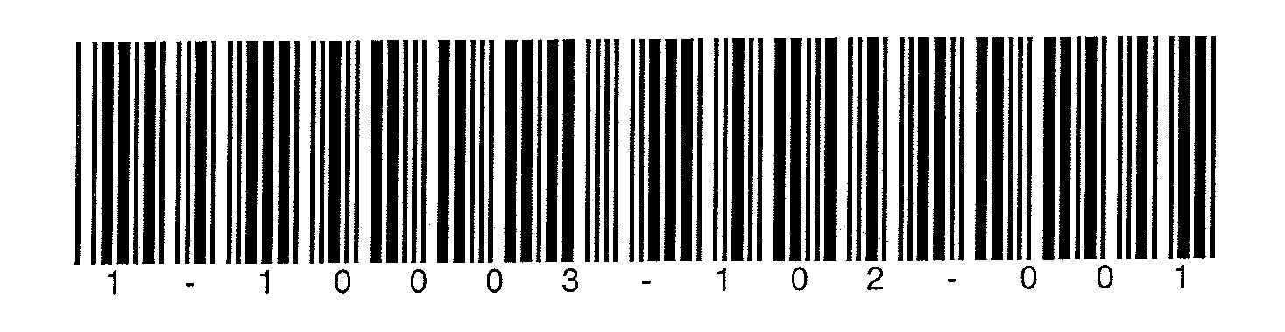

Version 062306_SAS_Nov2006

## DPBRN Logo

## Dental PBRN Study 2: Reasons for placing the first restoration on permanent tooth surface(s)

**Use this Data Collection Form whenever a study restoration is placed on a previously un-restored surface, which is not related to a current restoration, on a permanent tooth.**

**You may place multiple ‘first restorations’ on the same patient during the same visit. You can do so by filling in the details on this information sheet and then filling out a restoration data sheet for each restoration.**

**For each question, please indicate the answer that best applies by marking an “X” in the corresponding box like this:  It is very important that the responses be recorded within the space allotted.**

**When recording numerical responses, such as amounts or dates, one number should be entered in each box and every box should have a number in it. Therefore, it may be necessary to record leading zero*s* when the number requires fewer boxes than provided.**

**Completed form should be mailed to: Dental PBRN**

**College of Dentistry**

**PO Box 100415 Gainesville, FL 32610-0415**

Visit Date / / 200 ***Participant ID:*** _______ **PID** ___________________

mm dd y

**BDATE**

1. Patient Gender **BGENDER**

1  Male

2  Female

2. Patient Age in years  **BAGE**

3. Patient Race **BRACE**

1  White

2  Black or African-American

3  American Indian or Alaska Native

4  Asian

5  Native Hawaiian or Other Pacific Islander

6  Other (please specify) ______________________________ **BRACESPE**

4. Patient Ethnicity **BHISPANIC**

1  Hispanic or Latino

2  Not Hispanic or Latino

5. Does the patient have any dental insurance or third party coverage? **BDENINS**

1  Yes

2  No

**RESTORATION DATA SHEET**

6. On which tooth and surface(s) did you diagnose primary caries or a non-carious defect?

tooth number  **BTOHNUM**

tooth surface (mark all that apply)

1  Occlusal **BTOOCCL**

2  Mesial **BTOMESI**

3  Distal **BTODIST**

4  Buccal or Facial **BTOBUCC**

5  Lingual or Palatal **BTOLING**

6  Incisal **BTOINCI**

7. What is the ***main*** reason that you placed a

restoration in this tooth? (Please mark one

response only.) **BREASON**

1  Restoration of a non-carious

defect *(For example: abrasion /abfraction / erosion,*

*fractured tooth, unsightly area)*

**go to question 7d**

2  Primary caries *(The first caries lesion, which is not related to a current restoration, diagnosed on any tooth surface.)*

**🡪 go to question 7a**

**answer questions 7a – 7c only if “primary caries” was marked in question 7**

7a. What technique did you use to diagnose the

primary caries lesion? (Please mark all that apply.)

1  Clinical assessments including probing **BCLINASS**

2  Radiographs **BRADGRA**

3  Transillumination or optical technique (e.g., Diagnodent®) **BOPTTECH**

7b. How deep did you estimate that the deepest part

of the primary caries lesion was ***pre****operatively*? (Please mark one category only.) **BPREDEEP**

1  E1 (Outer ½ of Enamel)

2  E2 (Inner ½ of Enamel)

3  D1 (Outer ⅓ of Dentin)

4  D2 (Middle ⅓ of Dentin)

5  D3 (Inner ⅓ of Dentin)

6  Uncertain

7c. How deep did you estimate that the deepest part

of the primary caries lesion was ***post****operatively*?

(Please mark one category only.) **BPOSDEEP**

1  E1 (Outer ½ of Enamel)

2  E2 (Inner ½ of Enamel)

3  D1 (Outer ⅓ of Dentin)

4  D2 (Middle ⅓ of Dentin)

5  D3 (Inner ⅓ of Dentin)

**🡪 go to question 8**

**answer question 7d only if “restoration of non-carious defect” was marked in question 7**

7d. Why did you restore the non-carious defect?

(Please mark all that apply.)

1  Abrasion/abfraction/erosion lesion **BABRASN**

2  Developmental defect or hypoplasia **BDEFECT**

3  For cosmetic reasons **BCOSMET**

4  To restore an endodontically-treated tooth **BREENDO**

5  The tooth was fractured **BFRACTUR**

6  Other _________________________ **BOTREASN** **BSPEC**

8. Did you use a base, lining or bonding material?

(Please mark all that apply.)

1  None **BRENONE**

2  Resin-based bonding material **BRERESI**

3  Glass ionomer, resin-modified glass ionomer **BREIONO**

4  Calcium hydroxide-based cement or liner**BRECAOH**

5  Varnish (e.g., Copalite) **BREVARN**

6  Other (specify) __________________**BREOTHER**

**BRESPEC**

9. What material did you use for this restoration? (Please mark all that apply.)

1  Amalgam **BAMALG**

2  Composite resin, including compomer, directly placed (Brand:_______________________) **BDIRRESI**

**BRESIBR**

3  Indirect composite resin **BINDRESI**

4  Glass ionomer, resin-modified glass ionomer (Brand:_____________________________) **BIONOM** **BIONOBR**

5  Ceramic or porcelain **BCERAM**

6  Cast gold or other base metallic restoration**BMETAL**

7  Combined metal/ceramic restoration **BMETCERA**

8  Temporary restorative material **BTEMP**

10. Did you use a rubber dam during the restorative

procedure? **BREDAM**

1  Yes

2  No