

Study 1: Assessment of Caries Diagnosis and Caries Treatment

Completion Date / / 2006
mm dd
ADATE (or AMONTH and ADAY)

SECTION 1: Questions 1- 8 have to do with methods that you may use to diagnose dental caries. Please circle the one number that best corresponds to your answer. Patients can vary substantially from one practice to the next, but we are interested in the patients in YOUR practice.

- When you examine patients to determine if they have a caries lesion on a proximal (mesial or distal) surface, on a posterior tooth, on what percent of these patients do you use radiographs to help diagnose the lesion?
APROXX
1 – Never or 0%
2 – 1 to 24%
3 – 25 to 49%
4 – 50 to 74%
5 – 75 to 99%
6 – Every time or 100%

- When you examine patients to determine if they have a caries lesion on the occlusal surface, on what percent of these patients do you use radiographs to help diagnose the lesion?
AOCCLX
1 – Never or 0%
2 – 1 to 24%
3 – 25 to 49%
4 – 50 to 74%
5 – 75 to 99%
6 – Every time or 100%

- When you examine patients to determine if they have a primary occlusal caries lesion, on what percent of these patients do you use a dental explorer to help diagnose the lesion?
AOCCLEXP
1 – Never or 0%
2 – 1 to 24%
3 – 25 to 49%
4 – 50 to 74%
5 – 75 to 99%
6 – Every time or 100%

- When you examine patients to determine if they have a caries lesion at the margin of an existing restoration (recurrent/secondary caries) on what percent of these patients do you use a dental explorer to help diagnose the lesion?
AMARGEXP
1 – Never or 0%
2 – 1 to 24%
3 – 25 to 49%
4 – 50 to 74%
5 – 75 to 99%
6 – Every time or 100%

- When you examine patients to determine if they have a primary caries lesion on the occlusal surface, on what percent of these patients do you use laser fluorescence (for example, Diagnodent®)?
AOCCLASR
1 – Never or 0%
2 – 1 to 24%
3 – 25 to 49%
4 – 50 to 74%
5 – 75 to 99%
6 – Every time or 100%
6. When you examine patients to determine if they have a primary caries lesion, on what percent of these patients do you use air-drying to help diagnose the lesion?
AAIRDRY

1 – Never or 0% [Skip to question 7] ADRYSEC
2 – 1 to 24%
6b. Approximately how long do you dry the tooth surface?
1 – 1-2 seconds
2 – 3-4 seconds
3 – 5 seconds
4 – More than 5 seconds
3 – 25 to 49%
4 – 50 to 74%
5 – 75 to 99%
6 – Every time or 100%

7. When you examine patients to determine if they have a caries lesion on a proximal (mesial or distal) surface of an anterior tooth, on what percent of these patients do you use fiber optic transillumination to help diagnose the lesion?
APRFIBOP
1 – Never or 0%
2 – 1 to 24%
3 – 25 to 49%
4 – 50 to 74%
5 – 75 to 99%
6 – Every time or 100%

8. When you examine patients to determine if they have a caries lesion, on what percent of these patients do you use some sort of magnification to help diagnose the lesion?
AMAGNIFY
1 – Never or 0%
2 – 1 to 24%
3 – 25 to 49%
4 – 50 to 74%
5 – 75 to 99%
6 – Every time or 100%

SECTION 2: Questions 9-22 have to do with methods that you may use to prevent or treat dental caries. Please circle the one number that best corresponds to your answer.

The first 6 questions refer to patients 6 to 18 years old. Please skip to question 15 if you do not see any patients 6-18 years old:

9. Of patients 6 to 18 years old, for what percent do you apply dental sealants on the occlusal surfaces of at least one of their permanent teeth?
A6SEALT
1 – Never or 0%
2 – 1 to 24%
3 – 25 to 49%
4 – 50 to 74%
5 – 75 to 99%
6 – Every time or 100%

10. Of patients 6 to 18 years old, for what percent do you administer an in-office fluoride application, such as fluoride gel, fluoride varnish, or fluoride rinse?
A6OFF
1 – None or 0%
2 – 1 to 24%
3 – 25 to 49%
4 – 50 to 74%
5 – 75 to 99%
6 – All or 100%
11. Of patients 6 to 18 years old, for what percent do you recommend a non-prescription (over-the-counter) fluoride rinse?
A6NRHMF
1 – None or 0%
2 – 1 to 24%
3 – 25 to 49%
4 – 50 to 74%
5 – 75 to 99%
6 – All or 100%

12. Of patients 6 to 18 years old, for what percent do you provide a prescription for some form of fluoride?
A6RHMF
1 – None or 0%
2 – 1 to 24%
3 – 25 to 49%
4 – 50 to 74%
5 – 75 to 99%
6 – All or 100%

13. Of patients 6 to 18 years old, for what percent do you recommend an at-home regimen of chlorhexidine rinse?
A6HMCL
1 – None or 0%
2 – 1 to 24%
3 – 25 to 49%
4 – 50 to 74%
5 – 75 to 99%
6 – All or 100%

14. Of patients 6 to 18 years old, for what percent do you recommend sugarless chewing gum or xylitol chewing gum?
A6GUM
1 – None or 0%
2 – 1 to 24%
3 – 25 to 49%
4 – 50 to 74%
5 – 75 to 99%
6 – All or 100%

The next 6 questions refer to patients who are more than 18 years old. Please skip to question 21 if you do not see any patients who are more than 18 years old:

15. Of patients more than 18 years old with at least one posterior tooth, for what percent do you apply dental sealants on the occlusal surface of at least one tooth?
A18SEALT
1 – None or 0%
2 – 1 to 24%
3 – 25 to 49%
4 – 50 to 74%
5 – 75 to 99%
6 – All or 100%

16. Of patients more than 18 years old with at least one tooth, for what percent do you administer an in-office fluoride application, such as fluoride gel, fluoride varnish, or fluoride rinse?
A18FLUOR
1 – None or 0%
2 – 1 to 24%
3 – 25 to 49%
4 – 50 to 74%
5 – 75 to 99%
6 – All or 100%

17. Of patients more than 18 years old with at least one tooth, for what percent do you recommend a non-prescription (over-the-counter) fluoride rinse?
A18NRHMF
1 – None or 0%
2 – 1 to 24%
3 – 25 to 49%
4 – 50 to 74%
5 – 75 to 99%
6 – All or 100%

18. Of patients more than 18 years old with at least one tooth, for what percent do you provide a prescription for some form of fluoride?
A18RHMF
1 – None or 0%
2 – 1 to 24%
3 – 25 to 49%
4 – 50 to 74%
5 – 75 to 99%
6 – All or 100%

19. Of patients more than 18 years old with at least one tooth, for what percent do you recommend an at-home regimen of chlorhexidine rinse?
A18HMCL
1 – None or 0%
2 – 1 to 24%
3 – 25 to 49%
4 – 50 to 74%
5 – 75 to 99%
6 – All or 100%

20. Of patients more than 18 years old with at least one tooth, for what percent do you recommend sugarless chewing gum or xylitol chewing gum?
A18GUM
1 – None or 0%
2 – 1 to 24%
3 – 25 to 49%
4 – 50 to 74%
5 – 75 to 99%
6 – All or 100%

21. Do you assess caries risk for individual patients in any way?

AASSESS
1 – Yes
AASSDOC
a. I record the assessment on a special form that is kept in the patient chart. (Please include a copy of the form used when returning this questionnaire.)
b. I do not use a special form to make the assessment.
2 – No

SECTION 3: For questions 22-26, we are interested in what you believe are the most important factors when you design a treatment plan (including recall interval, interventions, and operative treatment). Please circle the number which best corresponds to your answer.

22. For patients 6 to 18 years old, how important is each of the factors below when you decide on a treatment plan? Please circle the letter “o” at the bottom of the list if you do not see patients 6-18 years old.

 | Not  at all  important | Slightly important | Moderately important | Very important | Extremely important
A6ACTCA  - Patient has one or more active caries lesions | 1 | 2 | 3 | 4 | 5
A6RECCA  - Patient has had caries recently | 1 | 2 | 3 | 4 | 5
A6STACA  - Caries status of the parents | 1 | 2 | 3 | 4 | 5
A6LREST  - Patient has several large restorations | 1 | 2 | 3 | 4 | 5
A6ORHYG  - Current oral hygiene | 1 | 2 | 3 | 4 | 5
A6DAPPL  - Presence of dental appliances | 1 | 2 | 3 | 4 | 5
A6NOWF  - Current use of fluorides by the patient | 1 | 2 | 3 | 4 | 5
A6DIET  - Current diet of the patient | 1 | 2 | 3 | 4 | 5
A6REDSA  - Decreased salivary function | 1 | 2 | 3 | 4 | 5
A6DRASS  - Your own subjective assessment about the patient | 1 | 2 | 3 | 4 | 5
A6PTPRO  - Patient’s (or guardian’s) understanding of caries progression | 1 | 2 | 3 | 4 | 5
A6PTRTN  - Patient’s (or guardian’s) commitment to return for follow-up | 1 | 2 | 3 | 4 | 5
A6PTAGE  - Patient’s age | 1 | 2 | 3 | 4 | 5
A6SES  - Patient’s socio-economic status | 1 | 2 | 3 | 4 | 5
A6NA
- Not applicable – I do not see any patients 6-18 years old

23. For patients more than 18 years old, how important is each of the factors below when you decide on a treatment plan? Please circle the letter “o” at the bottom of the list if you do not see patients 18 or older.
 | Not at all  important | Slightly important | Moderately important | Very important | Extremely important
A18ACTCA  - Patient has an active caries lesion | 1 | 2 | 3 | 4 | 5
A18RECCA  - Patient has had caries recently | 1 | 2 | 3 | 4 | 5
A18LREST  - Patient has several large restorations | 1 | 2 | 3 | 4 | 5
A18ORHYG  - Current oral hygiene | 1 | 2 | 3 | 4 | 5
A18DAPPL  - Presence of dental appliances | 1 | 2 | 3 | 4 | 5
A18NOWF  - Current use of fluorides by the patient | 1 | 2 | 3 | 4 | 5
A18DIET  - Current diet of the patient | 1 | 2 | 3 | 4 | 5
A18REDSA  - Decreased salivary function | 1 | 2 | 3 | 4 | 5
A18DRASS  - Your own subjective assessment about the patient | 1 | 2 | 3 | 4 | 5
A18PTPRO  - Patient’s understanding of caries progression | 1 | 2 | 3 | 4 | 5
A18PTRTN  - Patient’s commitment to return for follow-up | 1 | 2 | 3 | 4 | 5
A18PTAGE  - Patient’s age | 1 | 2 | 3 | 4 | 5
A18SES  - Patient’s socio-economic status | 1 | 2 | 3 | 4 | 5
A18RECES  - Recession or root exposure | 1 | 2 | 3 | 4 | 5
A18NA
- Not applicable – I do not see patients >18 y

24. What percent of patients in your practice are interested in an individualized caries preventive regimen?
APREVINT
1 – None or 0%
2 – 1 to 24%
3 – 25 to 49%
4 – 50 to 74%
5 – 75 to 99%
6 – All or 100%

25. For what percent of patients do you give individualized preventive treatment specifically for their needs?
APREVTRT
1 – None or 0%
2 – 1 to 24%
3 – 25 to 49%
4 – 50 to 74%
5 – 75 to 99%
6 – All or 100%

26. How strongly do you agree with this statement: "A dentist's assessment of caries risk for a patient can predict whether or not that patient develops new caries in the future"?
APREDCA
1 – Strongly disagree
2 – Somewhat disagree
3 – Neither agree nor disagree
4 – Somewhat agree
5 – Strongly agree

SECTION 4: Please use the following guide for the treatment codes used in questions 27-29. For each question, circle the letters which correspond to the treatment codes you would recommend for scenarios described. If treatment code “j” (other) is used, please specify. You may circle more than one treatment code per question.
 | Question 27 | Question 28 | Question 29
- No treatment today, follow the patient regularly | a | a | a
- Instruct patient in plaque removal for the affected area | b | b | b
- In-office fluoride | c | c | c
- Prescription for fluoride | d | d | d
- Recommend non-prescription fluoride | e | e | e
- Use sealant or unfilled resin over tooth | f | f | f
- Chlorhexidine treatment | g | g | g
- Polish, re-surface, or repair restoration, but not replace | h | h | h
- Replace entire restoration | i | i | i
- Other treatment [please specify] | j | j | j
For Questions 27-29: The patient is a 30-year old female with no relevant medical history. She has no complaints and is in your office today for a routine visit. She has been attending your practice on a regular basis for the past 6 years. (Circle your answers above)

- The patient has 5 existing restorations and is not missing any teeth. Indicate what treatment you would provide to the restoration shown by the arrow in the first picture on the left.
A27TRTA A27TRTB A27TRTC A27TRTD A27TRTE A27TRTF
A27TRTG A27TRTH A27TRTI A27TRTJ A27TRTSP

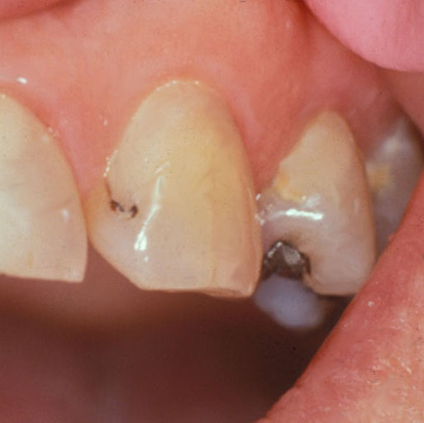

- Now imagine the patient has no other dental restorations than the one shown, no dental caries, and is not missing any teeth. Indicate what treatment you would provide to the restoration in the second picture on the left.

A28TRTA A28TRTB A28TRTC A28TRTD A28TRTE A28TRTF
A28TRTG A28TRTH A28TRTI A28TRTJ A28TRTSP

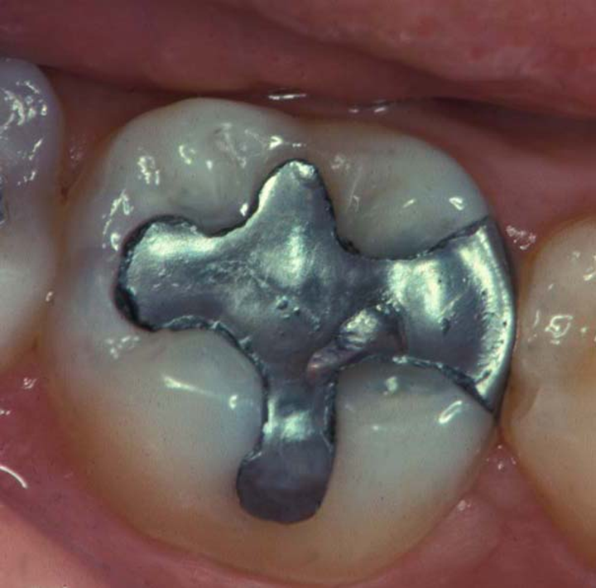

- The same patient has no other dental restorations than the one shown, no dental caries, and is not missing any teeth. Indicate what treatment you would provide to the restoration in the third picture on the left.

A29TRTA A29TRTB A29TRTC A29TRTD A29TRTE A29TRTF
A29TRTG A29TRTH A29TRTI A29TRTJ A29TRTSP

SECTION 5: Please use the following guide for the treatment codes used in questions 30-32.
For each question, circle the letters which correspond to the treatment codes you would recommend for each of the five cases. If treatment code “n” (other) is used, please specify. You may circle more than one treatment code per case.
- No treatment today, follow the patient regularly | h. Minimal drilling and preventive resin restoration
- In-office fluoride | i. Air abrasion and a sealant
- Recommend non-prescription fluoride | j. Air abrasion and preventive resin restoration
- Prescription for fluoride | k. Amalgam restoration
- Use sealant or unfilled resin over tooth | l. Composite restoration
- Chlorhexidine treatment | - Indirect restoration
g. Minimal drilling and sealant | n. Other treatment [Please specify] ___________

For Questions 30 and 31: The patient is a 30 year old female with no relevant medical history. She has no complaints and is in your office today for a routine visit. She has been attending your practice on a regular basis for the past 6 years.

30. Indicate how you would treat the tooth shown if the patient has no other teeth with dental restorations or dental caries and is not missing any teeth.

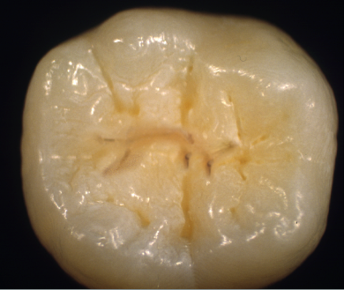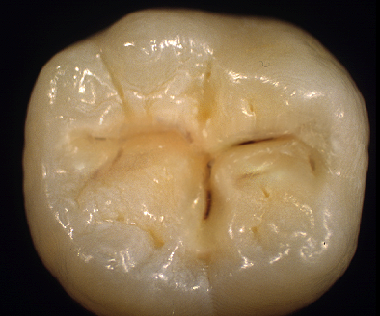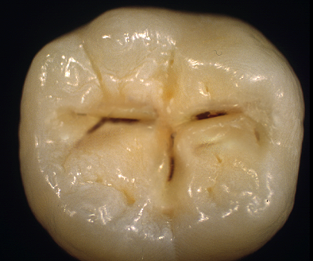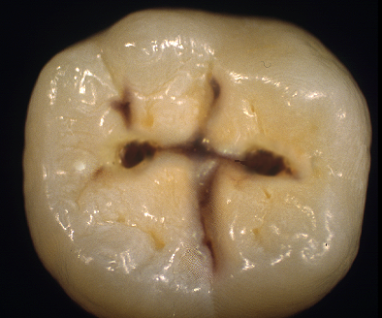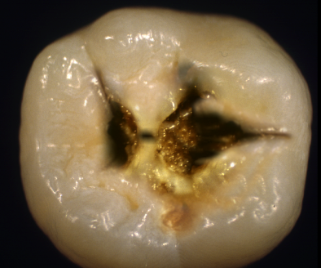

Reprinted from Espelid et al²² with permission

Case 1 Case 2 Case 3 Case 4 Case 5
a b c d e f g a b c d e f g a b c d e f g a b c d e f g a b c d e f g

h i j k l m n h i j k l m n h i j k l m n h i j k l m n h i j k l m n
a A30TRT1A A30TRT2A A30TRT3A A30TRT4A A30TRT5A
b A30TRT1B A30TRT2B A30TRT3B A30TRT4B A30TRT5B
c A30TRT1C A30TRT2C A30TRT3C A30TRT4C A30TRT5C
d A30TRT1D A30TRT2D A30TRT3D A30TRT4D A30TRT5D
e A30TRT1E A30TRT2E A30TRT3E A30TRT4E A30TRT5E
f A30TRT1F A30TRT2F A30TRT3F A30TRT4F A30TRT5F
g A30TRT1G A30TRT2G A30TRT3G A30TRT4G A30TRT5G
h A30TRT1H A30TRT2H A30TRT3H A30TRT4H A30TRT5H
i A30TRT1I A30TRT2I A30TRT3I A30TRT4I A30TRT5I
j A30TRT1J A30TRT2J A30TRT3J A30TRT4J A30TRT5J
k A30TRT1K A30TRT2K A30TRT3K A30TRT4K A30TRT5K
l A30TRT1L A30TRT2L A30TRT3L A30TRT4L A30TRT5L
m A30TRT1M A30TRT2M A30TRT3M A30TRT4M A30TRT5M
n A30TRT1N A30TRT2N A30TRT3N A30TRT4N A30TRT5N
n A30TR1SP A30TR2SP A30TR3SP A30TR4SP A30TR5SP

31. If the same patient has 12 teeth with existing dental restorations, heavy plaque and calculus, multiple
Class V white spot lesions, and is missing five teeth.

Case 1 Case 2 Case 3 Case 4 Case 5
a b c d e f g a b c d e f g a b c d e f g a b c d e f g a b c d e f g

h i j k l m n h i j k l m n h i j k l m n h i j k l m n h i j k l m n
a A31TRT1A A31TRT2A A31TRT3A A31TRT4A A31TRT5A
b A31TRT1B A31TRT2B A31TRT3B A31TRT4B A31TRT5B
c A31TRT1C A31TRT2C A31TRT3C A31TRT4C A31TRT5C
d A31TRT1D A31TRT2D A31TRT3D A31TRT4D A31TRT5D
e A31TRT1E A31TRT2E A31TRT3E A31TRT4E A31TRT5E
f A31TRT1F A31TRT2F A31TRT3F A31TRT4F A31TRT5F
g A31TRT1G A31TRT2G A31TRT3G A31TRT4G A31TRT5G
h A31TRT1H A31TRT2H A31TRT3H A31TRT4H A31TRT5H
i A31TRT1I A31TRT2I A31TRT3I A31TRT4I A31TRT5I
j A31TRT1J A31TRT2J A31TRT3J A31TRT4J A31TRT5J
k A31TRT1K A31TRT2K A31TRT3K A31TRT4K A31TRT5K
l A31TRT1L A31TRT2L A31TRT3L A31TRT4L A31TRT5L
m A31TRT1M A31TRT2M A31TRT3M A31TRT4M A31TRT5M
n A31TRT1N A31TRT2N A31TRT3N A31TRT4N A31TRT5N
n A31TR1SP A31TR2SP A31TR3SP A31TR4SP A31TR5SP

32. Now suppose the patient is a 12-year old child with no relevant medical history. The patient is in your office today for the first time for a routine visit. She has 5 restorations and moderate plaque. A rubber dam cannot be used.

Case 1 Case 2 Case 3 Case 4 Case 5
a b c d e f g a b c d e f g a b c d e f g a b c d e f g a b c d e f g

h i j k l m n h i j k l m n h i j k l m n h i j k l m n h i j k l m n
a A32TRT1A A32TRT2A A32TRT3A A32TRT4A A32TRT5A
b A32TRT1B A32TRT2B A32TRT3B A32TRT4B A32TRT5B
c A32TRT1C A32TRT2C A32TRT3C A32TRT4C A32TRT5C
d A32TRT1D A32TRT2D A32TRT3D A32TRT4D A32TRT5D
e A32TRT1E A32TRT2E A32TRT3E A32TRT4E A32TRT5E
f A32TRT1F A32TRT2F A32TRT3F A32TRT4F A32TRT5F
g A32TRT1G A32TRT2G A32TRT3G A32TRT4G A32TRT5G
h A32TRT1H A32TRT2H A32TRT3H A32TRT4H A32TRT5H
i A32TRT1I A32TRT2I A32TRT3I A32TRT4I A32TRT5I
j A32TRT1J A32TRT2J A32TRT3J A32TRT4J A32TRT5J
k A32TRT1K A32TRT2K A32TRT3K A32TRT4K A32TRT5K
l A32TRT1L A32TRT2L A32TRT3L A32TRT4L A32TRT5L
m A32TRT1M A32TRT2M A32TRT3M A32TRT4M A32TRT5M
n A32TRT1N A32TRT2N A32TRT3N A32TRT4N A32TRT5N
n A32TR1SP A32TR2SP A32TR3SP A32TR4SP A32TR5SP

SECTION 6: For questions 33 & 34, please circle the one number that corresponds to the lesion depth at which you think it is best to do a permanent restoration (composite, amalgam, etc.) instead of only doing preventive therapy?

For questions 33 and 34: The patient is a 30-year old female with no relevant medical history. She has no complaints and is in your office today for a routine visit. She has been attending your practice on a regular basis for the past 6 years.

- The patient has no dental restorations, no dental caries, and is not missing any teeth.

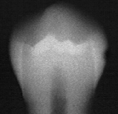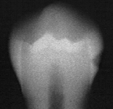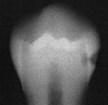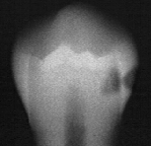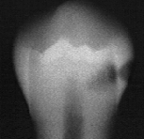
Reprinted from Espelid et al²² with permission

1 2 3 4 5
A33TRT
34. The patient has 12 teeth with existing dental restorations, heavy plaque and calculus, multiple Class V white spot lesions, and is not missing any teeth. At what lesion depth do you think it would be best to do a permanent restoration instead of only doing preventive therapy?

Reprinted from Espelid et al²² with permission
1 2 3 4 5
A34TRT

