

## Practice Impact Questionnaire

Your practitioner identifier is: XXXXXXXX **PRACID**

It is very important that ONLY YOU complete this questionnaire

because your responses will be compared to responses that you provided at an earlier time!

Please make sure that it is YOUR name that appears on the envelope!

## Date that you completed this questionnaire: CP2DATE

## Month Date Year (20xx)

# Instructions

Please answer each of the questions below based on your current practice patterns.

## Caries Diagnosis and Treatment

|  |  |
| --- | --- |
| 1. When you examine patients to determine if they have a **primary occlusal caries** lesion, on what percent of these patients do you use a **dental explorer** to help diagnose the lesion? **CP2Q1OCCLEXP** | 🞎 0 Never or 0%  🞎 1 1 – 24%  🞎 2 25 – 49%  🞎 3 50 – 74%  🞎 4 75 – 99%  🞎 5 Every time or 100% |
|  |  |
| 2. When you examine patients to determine if they have a **primary caries** lesion, on what percent of these patients do you use **air-drying** to help diagnose the lesion?  **CP2Q2AIRDRY** | 🞎 0 Never or 0% (skip to question 3)  🞎 1 1 – 24%  🞎 2 25 – 49%  🞎 3 50 – 74%  🞎 4 75 – 99%  🞎 5 Every time or 100% |
|  |  |
| 2.1 If you air-dry at least some, approximately how long do you dry the tooth surface? **CP2Q2DRYSEC** | 🞎 1 1 to 2 seconds  🞎 2 3 to 4 seconds  🞎 3 5 seconds  🞎 4 More than 5 seconds |
|  |  |
|  |  |
| 3. Do you assess caries risk for individual patients in any way? **CP2Q3ASSESS** | 🞎 1 Yes  🞎 A I record the assessment on a special form that is kept in the patient chart.  🞎 B I do not use a special form to make the assessment.  **CP2Q3ASSDOC**  🞎 2 No |

|  |
| --- |
| **For the following questions (4 and 5):** We are interested in your opinion on the following case:  The patient is a 30-year old female with no relevant medical history. She has no complaints and is in your office today for a routine visit. She has been attending your practice on a regular basis for the past 6 years. |
| Indicate how you would treat the tooth shown if the patient has no other teeth with dental restorations or dental caries and is not missing any teeth.  **If treatment code “other” is used, please specify. You may check more than one treatment code per case.** |

|  |  |  |
| --- | --- | --- |
|  | 4. How would you treat the tooth shown at the left? | |
|  | 🞎 No treatment today, follow the patient regularly **CP2Q4TRTA**  🞎 In-office fluoride **CP2Q4TRTB**  🞎 Recommend non-prescription fluoride **CP2Q4TRTC**  🞎 Prescription for fluoride **CP2Q4TRTD**  🞎 Use sealant or unfilled resin over tooth **CP2Q4TRTE**  🞎 Chlorhexidine treatment **CP2Q4TRTF**  🞎 Minimal drilling and sealant **CP2Q4TRTG** | 🞎 Minimal drilling and preventive resin restoration **CP2Q4TRTH**  🞎 Air abrasion and a sealant **CP2Q4TRTI**  🞎 Air abrasion and preventive resin restoration **CP2Q4TRTJ**  🞎 Amalgam restoration **CP2Q4TRTK**  🞎 Composite restoration **CP2Q4TRTL**  🞎 Indirect restoration **CP2Q4TRTM**  🞎 Other treatment **[Please specify] CP2Q4TRT**  **____CP2Q4TRTSP________________________** |
|  |  |  |
|  | 5. How would you treat the tooth shown at the left? | |
|  | 🞎 No treatment today, follow the patient regularly **CP2Q5TRTA**  🞎 In-office fluoride **CP2Q5TRTB**  🞎 Recommend non-prescription fluoride **CP2Q5TRTC**  🞎 Prescription for fluoride **CP2Q5TRTD**  🞎 Use sealant or unfilled resin over tooth **CP2Q5TRTE**  🞎 Chlorhexidine treatment **CP2Q5TRTF**  🞎 Minimal drilling and sealant **CP2Q5TRTG** | 🞎 Minimal drilling and preventive resin restoration **CP2Q5TRTH**  🞎 Air abrasion and a sealant **CP2Q5TRTI**  🞎 Air abrasion and preventive resin restoration **CP2Q5TRTJ**  🞎 Amalgam restoration **CP2Q5TRTK**  🞎 Composite restoration **CP2Q5TRTL**  🞎 Indirect restoration **CP2Q5TRTM**  🞎 Other treatment **[Please specify] CP2Q5TRTN**  **_____CP2Q5TRTSP________________________** |

## Deep Caries Treatment and Diagnosis

|  |  |  |
| --- | --- | --- |
| 6. In a patient with deep caries (occlusal) and a possible mild pulpitis on a posterior tooth where the caries radiographically appears to extend to the pulp, what percentage of the time do you:  (Percentages should add to 100%) | Stop before removing all caries and perform an indirect pulp cap: | **CP2Q6IPC**  _______________ |
| Remove all caries and proceed with a direct pulp cap: | **CP2Q6DPC**  _______________ |
| Remove all caries and proceed with endodontic related procedures: | **CP2Q6ENDO**  _______________ |
|  |  |  |
| Deep Caries Patient Scenario Patient Edwards is a 25 year-old male with a visible cavitation into the dentin in the central fossa of tooth #30 (right mandibular first molar according to the ADA coding system). Overall patient Edwards has just two enamel lesions on smooth surfaces, in addition to the lesion on #30, which the bitewing radiograph indicates is deep. The tooth responds to cold and the pain lasts < 3 seconds.  Bitewing radiograph of patient Edward’s tooth #30: | | |
|  | | |
| 7. Upon opening the tooth and during excavation of the caries you realize that the lesion is deeper than anticipated and may involve the mesial buccal pulp horn. You would usually: **CP2Q7TRT** | 🞎**A**  Continue and remove all the decay  🞎**B** Stop removing decay near the pulp horn and remove it elsewhere  🞎**C** Temporize and treat or refer the tooth for endodontics | |
|  |  | |

## Pulp Capping

|  |  |
| --- | --- |
| 8. Which of the following pulp capping materials do you use **most often** in your practice (choose one)? **CP2Q8PCMAT** | 🞎 1 Mineral Trioxide Aggregate (MTA)  🞎 2 Calcium Hydroxide  🞎 3 Glass Ionomer  🞎 4 Dentine Bonding System  🞎 5 Other (please specify)  **CP2Q8PCMATOTSP**  ______________________________ |

## Third Molar Extraction

|  |  |
| --- | --- |
| 9. What percentage of your patients do you refer for third molar extraction *by the age of 20*? **CP2Q93MEPCT** | 🞎 1 < 20%  🞎 2 20 – 40%  🞎 3 40 – 60%  🞎 4 60 – 80%  🞎 5 > 80%  🞎 8  No pediatric patients  🞎 9  Cannot provide a meaningful estimate |
| 10. Which statement best describes your philosophy on third molar referrals?  **CP2Q103MEPHI** | 🞎 1 I recommend removal of most third molars for preventive reasons.  🞎 2 I recommend removal of third molars if they are asymptomatic but have a poor eruption path (e.g., full/partial impaction), or do not appear to have sufficient space for eruption.  🞎 3 I recommend removal of third molars only if a patient presents with symptoms or pathology associated with third molars. |

## Hypersensitivity

|  |  |
| --- | --- |
| 11. What types of dentin hypersensitivity treatments do you routinely use or recommend for your patients? (check all that you use) | 🞎 Dentin bonding agents **CP2Q11DENBOND**  🞎 Oxalate or bioglass containing material **CP2Q11OXAL**  🞎 Fluoride containing material **CP2Q11FLUO**  🞎 Chemical treatment (e.g. potassium nitrate) **CP2Q11CHEMTRT**  🞎 Toothpaste or rinse **CP2Q11TOOTHPAST**  🞎 Other **CP2Q11OTHER**  🞎 Nothing **CP2Q11NONE** |

## Caries Risk Assessment

|  |  |
| --- | --- |
| 12. Do you use any in-office tests to assess caries risk? **CP2Q12IOTASS** | 🞎 1 Yes  🞎 2 No |

## Endodontic Treatment and Restoration Outcome

|  |  |
| --- | --- |
| 13. One of your regular patients presents with pain in tooth #13. Upon clinical inspection the lingual cusp has fractured to just below the gingival margin and there is extensive decay beneath the large MOD composite restoration. You are able to diagnose a condition of irreversible pulpitis but there is no radiographic evidence of periapical pathosis.  You would at this point recommend to your patient that **you**: **CP2Q13IPTRT** | 🞎 1 Initiate endodontic treatment leading to placement of a post and core followed by a full crown.  🞎 2 Extirpate the pulp, temporize and **refer** for endodontic treatment and later you would place a post and core followed by a full crown.  🞎 3 Extract the tooth and place an immediate implant fixture that you would later restore with an implant crown.  🞎 4 Extirpate the pulp, temporize and **refer** the patient to an oral surgeon or periodontist for extraction and placement of an implant fixture that you would later restore with an implant crown.  🞎 5 Extract the tooth and **refer** the patient to an oral surgeon or periodontist for placement of an implant fixture that you would later restore with an implant crown. |

## Where do you get information?

In the next series of questions, we would like to assess where you look for information and updates on dentistry.

|  |  |
| --- | --- |
| 14. Which of the following dental journals do you regularly read (check all that you regularly read)? | 🞎 American Dental Association News **CP2Q14ADA**  🞎 J of the American Dental Association **VCP2Q14JADA**  🞎 Compendium **CP2Q14COMPEND**  🞎 Dentistry Today **VDENTRTOD**  🞎 J Esthetic & Restorative Dentistry **CP2Q14JERDENTR**  🞎 General Dentistry **CP2Q14GENDENTR**  🞎 Inside Dentistry **CP2Q14INSDENTR**  🞎 Operative Dentistry **CP2Q14OPERDENTR**  🞎 J Prosthetic Dentistry **CP2Q14JPROSDENTR**  🞎 Quintessence **CP2Q14QUINT**  🞎 Other state or local publication (US, Canadian or European): _ **CP2Q14STLOPUB**__ **CP2Q14STLOPUBSP** __  🞎 Other US or Canadian publication: __**CP2Q14USCAPUB** ____ **CP2Q14USCAPUBSP**  🞎 Other European publication: ___ **CP2Q14EURPUB** ____ **CP2Q14EURPUBSP**___ |
|  |  |
|  |  |
| 15. Where do you most frequently read journals? **CP2Q15JREADFM** | 🞎 1 Print  🞎 2 Online |
|  |  |
| 16. Where do you get most of your Continuing Dental Education (CDE) credits? (Please choose one) **CP2Q16CDECRED** | 🞎 1 State or local dental meetings  🞎 2 National dental meetings  🞎 3 Online CDE services  🞎 4 Other CDE services (e.g., tapes, journal articles)  🞎 5 Symposiums or other offerings by a school of dentistry  🞎 6 Other: _______ **CP2Q16CDECOTSP**________ |

|  |  |  |  |
| --- | --- | --- | --- |
| 17. Please rank each of the following with regard to ***which have the greatest influence on how you practice***. | | | |
|  |  |  |  |
|  | Little Influence | **Some Influence** | **Most Influence** |
| a. Printed peer-reviewed journals (e.g. J American Dental Association, Operative Dentistry) **CP2Q17PRJINF** | 🞎 | 🞎 | 🞎 |
| b. Printed non-peer-reviewed journals (e.g. Dental Products Report) **CP2Q17NPRJINF** | 🞎 | 🞎 | 🞎 |
| c. Online journals or newsletters **CP2Q17OJNINF** | 🞎 | 🞎 | 🞎 |
| d. Online CDEs **CP2Q17OCDEINF** | 🞎 | 🞎 | 🞎 |
| e. Online chatrooms or other interactive online services **CP2Q17OSINF** | 🞎 | 🞎 | 🞎 |
| f. Web searches (e.g. Google, PubMed) **CP2Q17WEBSINF** | 🞎 | 🞎 | 🞎 |
| g. Informal conversation with colleagues  **CP2Q17CCINF** | 🞎 | 🞎 | 🞎 |
| h. Study or journal clubs **P2Q17SCLUBINF** | 🞎 | 🞎 | 🞎 |
| i. State or local dental meetings **CP2Q17SDMINF** | 🞎 | 🞎 | 🞎 |
| j. National dental meetings **CP2Q17NDMINF** | 🞎 | 🞎 | 🞎 |
| k. Symposiums or other offerings by a school of dentistry **CP2Q17SCHINF** | 🞎 | 🞎 | 🞎 |
| l. Symposiums or other offerings by a private institute or organization (e.g. Kois Center, Pankey Institute) **CP2Q17PIOINF** | 🞎 | 🞎 | 🞎 |

|  |  |  |  |
| --- | --- | --- | --- |
| 18. How frequently do you make use of the following resources for practice guidance?  “Rarely” means < 10% of when available or once per year  “Sometimes” means 10 – 50% of when available or 1 – 6 times per year  “Frequently” means > 50% of when available or > 6 times per year | | | |
|  |  |  |  |
|  | Never | Rarely | **Sometimes** | **Quite Frequently or Every Time Available** |
| a. Printed peer-reviewed journals (e.g. J American Dental Association, Operative Dentistry) **CP2Q18PRJPG** | 🞎 | 🞎 | 🞎 | 🞎 |
| b. Printed non-peer-reviewed journals (e.g. Dental Products Report) **CP2Q18NPRJPG** | 🞎 | 🞎 | 🞎 | 🞎 |
| c. Online journals or newsletters **CP2Q18OJNPG** | 🞎 | 🞎 | 🞎 | 🞎 |
| d. Online CDEs **CP2Q18OCDEPG** | 🞎 | 🞎 | 🞎 | 🞎 |
| e. Online chat rooms or other interactive online services **CP2Q18IOSPG** | 🞎 | 🞎 | 🞎 | 🞎 |
| f. Web searches (e.g. Google, PubMed) **CP2Q18WEBSPG** | 🞎 | 🞎 | 🞎 | 🞎 |
| g. Informal conversation with colleagues **CP2Q18ICCPG** | 🞎 | 🞎 | 🞎 | 🞎 |
| h. Study or journal clubs **CP2Q18SCLUBPG** | 🞎 | 🞎 | 🞎 | 🞎 |
| i. State or local dental meetings **CP2Q18SDMPG** | 🞎 | 🞎 | 🞎 | 🞎 |
| j. National dental meetings **CP2Q18NDMPG** | 🞎 | 🞎 | 🞎 | 🞎 |
| k. Symposiums or other offerings by a school of dentistry **CP2Q18SCHPG** | 🞎 | 🞎 | 🞎 | 🞎 |
| l. Symposiums or other offerings by a private institute or organization (e.g. Kois Center, Pankey Institute)  **CP2Q18PIOPG** | 🞎 | 🞎 | 🞎 | 🞎 |

## Questions 19-21 have to do with methods that you may use to diagnose dental caries. Please circle the one number that best corresponds to your answer. Patients can vary substantially from one practice to the next, but we are interested in the patients in YOUR practice.

19. When you examine patients to determine if they have a **primary caries** lesion on the **occlusal** surface, on

what percent of these patients do you use **laser fluorescence** (for example, Diagnodent®)?

**1** – Never or 0% **CP2Q19OCCLASR**

**2** – 1 to 24%

**3** – 25 to 49%

**4** – 50 to 74%

**5** – 75 to 99%

**6** – Every time or 100%

20. When you examine patients to determine if they have a **caries** lesion on a **proximal** (mesial or distal)

surface of an anterior tooth, on what percent of these patients do you use **fiber optic** transillumination

to help diagnose the lesion? **CP2Q20PRFIBOP**

**1** – Never or 0%

**2** – 1 to 24%

**3** – 25 to 49%

**4** – 50 to 74%

**5** – 75 to 99%

**6** – Every time or 100%

21. When you examine patients to determine if they have a **caries** lesion, on what percent of these patients do

you use some sort of **magnification** to help diagnose the lesion? **CP2Q21MAGNIFY**

**1** – Never or 0%

**2** – 1 to 24%

**3** – 25 to 49%

**4** – 50 to 74%

**5** – 75 to 99%

**6** – Every time or 100%



|  |  |  |  |
| --- | --- | --- | --- |
| **Please use the following guide for the treatment codes used in questions 22-24. For each question, circle the letters which correspond to the treatment codes you would recommend for scenarios described. If treatment code “j” (other) is used, please specify. You may circle more than one treatment code per question.** | | | |
|  | Question 22 | Question 23 | Question 24 |
| 1. No treatment today, follow the patient regularly | **a** | **a** | **a** |
| 1. Instruct patient in plaque removal for the affected area | **b** | **b** | **b** |
| 1. In-office fluoride | **c** | **c** | **c** |
| 1. Prescription for fluoride | **d** | **d** | **d** |
| 1. Recommend non-prescription fluoride | **e** | **e** | **e** |
| 1. Use sealant or unfilled resin over tooth | **f** | **f** | **f** |
| 1. Chlorhexidine treatment | **g** | **g** | **g** |
| 1. Polish, re-surface, or repair restoration, but not replace | **h** | **h** | **h** |
| 1. Replace entire restoration | **i** | **i** | **i** |
| 1. Other treatment **[please specify]** | **j** | **j** | **j** |

**For Questions 22-24:** The patient is a 30-year old female with no relevant medical history. She has no complaints and is in your office today for a routine visit. She has been attending your practice on a regular basis for the past 6 years. **(Circle your answers above)**

1. The patient has 5 existing restorations and is not missing any teeth. Indicate what treatment you would provide to the restoration shown by the arrow in the first picture on the left.

**CP2Q22TRTA CP2Q22TRTB CP2Q22TRTC CP2Q22TRTD   
 CP2Q22TRTE CP2Q22TRTF CP2Q22TRTG CP2Q22TRTH   
 CP2Q22TRTI CP2Q22TRTJ CP2Q22TRTSP**

Reprinted from Mjör 2005 with permission

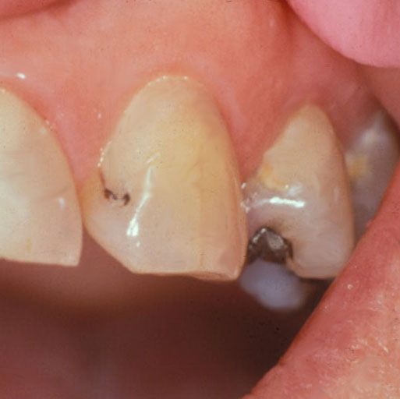

Reprinted from Mjör 2005 with permission

23. Now imagine the patient has no other dental restorations than the

one shown, no dental caries, and is not missing any teeth. Indicate

what treatment you would provide to the restoration in the second

picture on the left.

**CP2Q23TRTA CP2Q23TRTB CP2Q23TRTC CP2Q23TRTD CP2Q23TRTE CP2Q23TRTF CP2Q23TRTG CP2Q23TRTH   
CP2Q23TRTI CP2Q23TRTJ CP2Q23TRTSP**

24. The same patient has no other dental restorations than the one

shown, no dental caries, and is not missing any teeth. Indicate

what treatment you would provide to the restoration in the third

picture on the left.

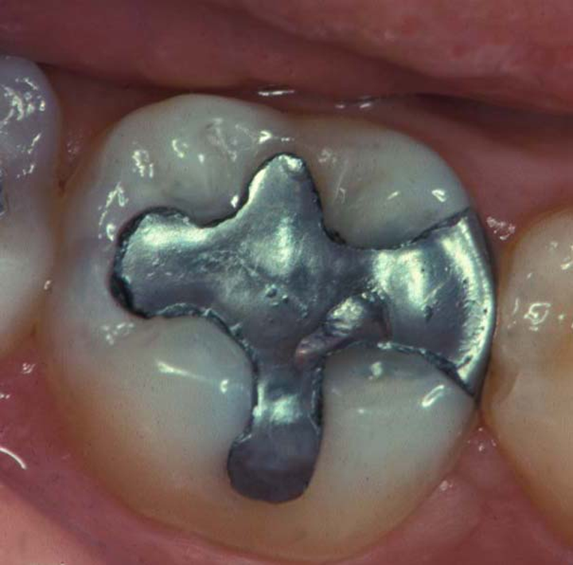

Courtesy of Dr. Ivar Mjör

**CP2Q24TRTA CP2Q24TRTB CP2Q24TRTC CP2Q24TRTD CP2Q24TRTE CP2Q24TRTF CP2Q24TRTG CP2Q24TRTH   
CP2Q24TRTI CP2Q24TRTJ CP2Q24TRTSP**

**For question 25, please circle the one number that corresponds to the lesion depth at which you think it is best to do a permanent restoration (composite, amalgam, etc.) instead of only doing preventive therapy.**

**For question 25:** The patient is a 30-year old female with no relevant medical history. She has no complaints and is in your office today for a routine visit. She has been attending your practice on a regular basis for the past 6 years.

25. The patient has no dental restorations, no dental caries, and is not missing any teeth. **CP2Q25TRT**

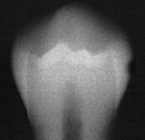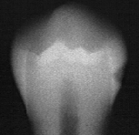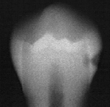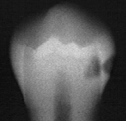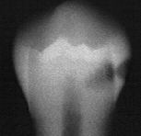

Reprinted from Espelid et al 1997 with permission

**1 2 3 4 5**