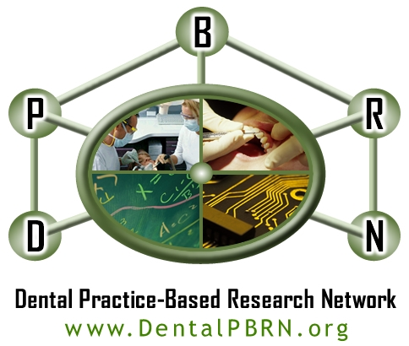

Blood Sugar Testing in Dental Practice: Patient Questionnaire

Thank you very much for agreeing to participate in this research study. Your answers to the questions below will help us to evaluate the usefulness of blood sugar testing in dental practice. These answers are anonymous and will not be shared with the dental practice or any member of its staff. When you are finished, please fold this paper and place it in the sealed box marked Blood Sugar Testing. This box will be picked up weekly by our study coordinator and opened at the University of Alabama at Birmingham, where the answers will be entered into a computer. All information is and will remain strictly confidential. We appreciate your help!

Agree disagree

Overall, I think glucose testing 1 2 3 4 5
in the Dental Office is a good idea.

Having my glucose tested
today was easy. 1 2 3 4 5

This test gave me, my dentist
and my doctor useful information. 1 2 3 4 5

Testing for glucose shows a
high level of care in this office. 1 2 3 4 5

I am likely to refer friends
and family to this practice. 1 2 3 4 5

Thank you!

Please place this paper into the box marked “DPBRN Study 10.”

For the following questions, please circle a number from 1 (strongly agree) to 5 (strongly disagree). There are no right or wrong answers. Please provide only one answer for each question.

Strongly Disagree Neutral Agree Strongly
Disagree Agree__

Overall, I think blood sugar testing 1 2 3 4 5
in the Dental Office is a good idea.
OGOOD

Having my blood sugar tested
today was easy. 1 2 3 4 5
OEASY

This test gave me useful information. 1 2 3 4 5
OUSEFUL

Testing for glucose shows a
high level of care in this office. 1 2 3 4 5
OHICARE

I am more likely to refer friends
and family to this practice because
blood sugar testing is offered here.. 1 2 3 4 5
OREFER
Thank you!

Please place this paper into the box marked “ Blood Sugar Testing in Dental Practice.”

