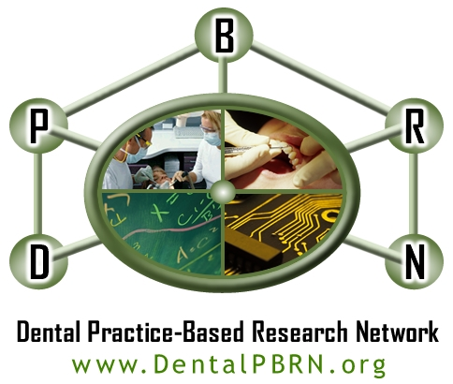

Blood Sugar Testing in Dental Practice
End of Study Practice Interview of the Participating Practitioner-Investigator
- Who performed the blood sugar testing in your practice? (Check all that apply). OWHO
Dentist
Hygienist
Dental Assistant
Other (please specify): _______ OWHOSP________________________

- Where was the testing performed? (Check all that apply) OWHERE
Regular dental operatory
Hygienist’s operatory
Exam only operatory
Other location (please describe): _________ OWHERESP_________________

- Was the testing well-received by patients? OWERVD
Yes
No
Comments: ______________ OWERVDSP___________________________

- Was testing easy to perform by the end of the study? OEASY
Yes
No
Comments: ___________ OEASYSP____________________________________

- How long did the testing for each patient last on average by the end of the study? OHOWLONG
<2 min
2-5 min
>5 min

- Was testing disruptive to the regular run of the practice by the end of the study? ODISRUP
Yes
No
Comments: _______ ODISRUPSP__________________________________________

- Do you now feel that routine blood glucose testing is: OBENIF
Beneficial to the practice
Detrimental to the practice
Indifferent
Comments: __________ OBENIFSP_______________________________________

- Do you think routine blood glucose testing for patients at risk for or diagnosed with diabetes should be implemented in dental practice? OGLUIMP
Yes
No
Comments: _________ OGLUIMPSP___________________________________________

- What barriers MUST be overcome before you would do routine blood glucose testing in your practice in the future? (Check all that apply)
Insurance companies must provide reimbursement for testing OGLUBARINC
The testing procedure would have to be easier OGLUBARTST
Patients would have to be more demanding of it OGLUBARDMD
Other (please specify): OGLUBAROTH ________ OGLUBAROTHSP__________________

