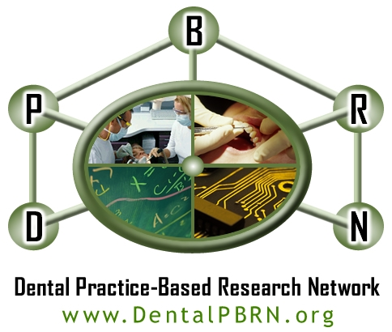

Study 11: Patient satisfaction with dental restorations (Patient Survey)

INSTRUCTIONS: Please complete this survey tonight or tomorrow - after any numbness has worn off. Do not return this survey to your dentist. Mail your completed survey in the attached envelope. Please include the compensation form, with your mailing address, so that we can send you your compensation.

We want to know how satisfied you are with your dental filling and dental visit. Please circle the NUMBER that best indicates how much you agree or disagree with each statement.

Completion Date:
(Please write in the date that you are filling out this form.)

200

Month Day Year

DCOMMON DCOMDAY DCOMYR
 | Strongly Disagree | Disagree | Neither Agree nor Disagree | Agree | Strongly Agree
- I am satisfied with the amount of trust that I can place in my dentist. DTRUST | 1 | 2 | 3 | 4 | 5
- I am satisfied with how the filling feels with hot or cold foods or drink. DFEELS | 1 | 2 | 3 | 4 | 5
- I am satisfied that I was able to ask questions about the dental procedure. DASKQUES | 1 | 2 | 3 | 4 | 5
- I am satisfied with the quality of the dental work. DQUALITY | 1 | 2 | 3 | 4 | 5
- I am satisfied with how friendly and courteous the staff were. DSTAFF | 1 | 2 | 3 | 4 | 5
- I am satisfied with how long I had to wait in the waiting room. DWAIT | 1 | 2 | 3 | 4 | 5
- I am satisfied with how my dentist limited pain during the procedure. DLMTPAIN | 1 | 2 | 3 | 4 | 5
- I am satisfied that the filling was not sensitive when I bit down on it. DNOSENS | 1 | 2 | 3 | 4 | 5
- I am satisfied with how much my dentist cared about me as a person. DCARE | 1 | 2 | 3 | 4 | 5
- I am satisfied with how my dentist tried to limit my fear and anxiety. DLMTFEAR | 1 | 2 | 3 | 4 | 5

Please TURN OVER to complete the back

 | Strongly Disagree | Disagree | Neither Agree nor Disagree | Agree | Strongly Agree
- I am satisfied with how long I expect the filling to last. DTIME | 1 | 2 | 3 | 4 | 5
- I am satisfied with how my dentist gave me a choice between different materials to fix my tooth. DCHOICE | 1 | 2 | 3 | 4 | 5
- I am satisfied with how gentle my dentist was when working in my mouth. DGENTLE | 1 | 2 | 3 | 4 | 5
- I am satisfied with how the dental procedure was explained before it was started. DEXPLAIN | 1 | 2 | 3 | 4 | 5
- I am satisfied with the friendliness of my dentist. DFRIENDL | 1 | 2 | 3 | 4 | 5
- I am satisfied with the skill of my dentist. DSKILL | 1 | 2 | 3 | 4 | 5
- I am satisfied that my dentist’s fee was reasonable for the work done. DFEE | 1 | 2 | 3 | 4 | 5
- I am satisfied with how clean and organized the office was. DCLEAN | 1 | 2 | 3 | 4 | 5
- I am satisfied that the filling feels smooth when I touch it with my tongue. DSMOOTH | 1 | 2 | 3 | 4 | 5
- I am satisfied with how the filling looks. DLOOK | 1 | 2 | 3 | 4 | 5

 | Poor | Fair | Neutral | Good | Excellent
- Overall, how would you rate the technical abilities of the dentist?  DOVERALL | 1 | 2 | 3 | 4 | 5

 | Not at all Satisfied | Slightly Satisfied | Moderately Satisfied | Very Satisfied | Extremely Satisfied
- Overall, how satisfied were you with all aspects of your dental treatment and visit? DDRTECH | 1 | 2 | 3 | 4 | 5

Completed form should be mailed to: Andrea Mathews
Dental PBRN Program Manager
SDB Box 39 1919 7th Avenue South Birmingham, Alabama 35294-0007

