
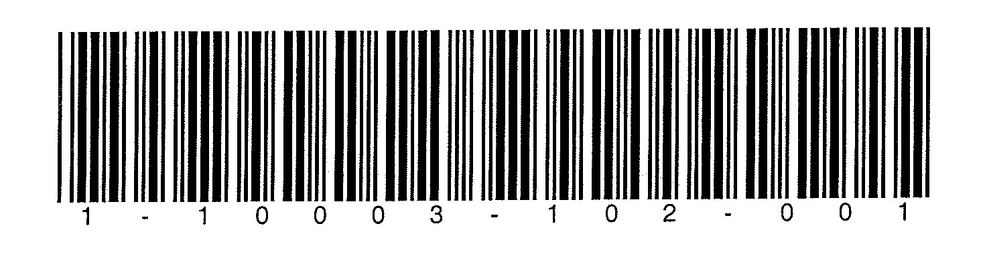

Study 11: Patient satisfaction with dental restorations (Dentist Survey)

INSTRUCTIONS: Below are statements about the dental visit. Please circle the NUMBER that best indicates how much you agree or disagree with each statement.

 | Strongly Disagree | Somewhat Disagree | Neither Agree or Disagree | Somewhat agree | Strongly Agree
- The restoration procedure went without complications. DNOCOMP | 1 | 2 | 3 | 4 | 5
- The patient had a strong preference for the restoration material that I used today. DSPMTRL | 1 | 2 | 3 | 4 | 5
- The patient perceived me as friendly.  DFRIEND | 1 | 2 | 3 | 4 | 5
- The filling procedure was painful for this patient today. DPAINFUL | 1 | 2 | 3 | 4 | 5
- The patient was anxious during the restorative procedure(s) today.  DANXIOUS | 1 | 2 | 3 | 4 | 5
- The patient was interested in information about the restorative procedure. DINTEREST | 1 | 2 | 3 | 4 | 5

 | Not at all Satisfied | Slightly Satisfied | Moderately Satisfied | Very Satisfied | Extremely Satisfied
- Overall, how satisfied was the patient with all aspects of the dental treatment and visit? DSATISF | 1 | 2 | 3 | 4 | 5

 | Poor | Fair | Neutral | Good | Excellent
- Overall, how would the patient rate your technical abilities for this restorative procedure(s)? DOWNTEC | 1 | 2 | 3 | 4 | 5

