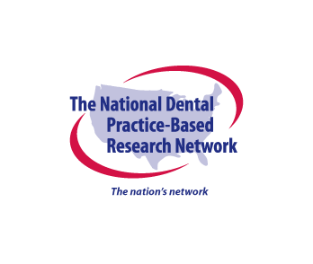Submission Checklist

Manuscripts and other documents are required to adhere to the National Dental PBRN submission guidelines. Please ensure that the following information is include in the abstract, manuscript and/or presentation prior to submitting to the Publications & Presentations Committee (P&P).

This form should be completed and attached when submitting your document for review. Failure to attach this form will cause your submission to be returned asking for its completion prior to the P&P Committee review.

**All submissions should include the below:**

Regional Representation (If select regions are not represented, please provide a brief justification following discussion with the Node Director)

Western

Midwest

Southwest

South Central

South Atlantic

Northeast

National Dental PBRN Collaborative Group should be the last named entity of authors.

“National Dental PBRN” or “National Dental Practice-Based Research Network” is in the title

NIDCR funding U19-DE-28717 is acknowledged

Target journal communicated to the P&P Committee

This version of the manuscript is the one that will be sent to the journal

The following statement is included in the Acknowledgments section:

Opinions and assertions contained herein are those of the authors and are not to be construed as necessarily representing the views of the respective organizations or the National Institutes of Health.

**Comments**: Click or tap here to enter text.

I affirm that the above items have been incorporated into this version of the manuscript.

Sign: Click or tap here to enter text.